**World Quant University**

**Professor: Ivan Blanco**

**Alpha Design I**

Nikolas Lippmann Pareschi - [nikolaslippmann@gmail.com](mailto:nikolaslippmann@gmail.com)

**Unit 5 - Assignment**

Provide a comparative analysis of the following different order execution types:

* + Market Order

A market order will cost for a buy order the first ask in the book (in case the volume is lower than the number offered in the lowest ask of the book):

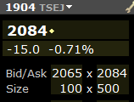

For example, one should be able to buy instantly with a market order until 500 units of the share 1904 of Tokyo Exchange (the picture is delayed data from Interactive Brokers). In case of a sell order, one should be able to sell until100 units, which is the highest bid of the book, for 2065. With market orders you are totally sure that your order will be executed at the price of the ask (buy) / bid (sell) if the volume is lower than the number offered in the book. Breakout systems usually use market orders, they need to be executed fast. When we move to swing and position trade the speed is not that important anymore and one can start using limit orders.

* + Limit Order

With a limit order you place the order as an ask in case you are selling a security and you can place the order as a bid in case you are buying the security. For example, in the case of 1904:



one can sell 100 stocks of1904 (Japanese and Singaporean stocks usually have number instead of names) placing an ask of 2080. The new ask in the book will be 2080 instead of 2084. One needs to wait a buyer accepting the price of 2080. It can take seconds, minutes, hours or even days. The bid / ask is not static and it can start moving down also. If that happens one needs to update his ask (sell case). The logic is the same when one wants to buy. It places a bid in the book. For example, one could place a bid above to buy 200 shares of 1904 for 2070.

Limit orders have the advantage of “capturing” the slippage in your favor when executed. But you don’t have any guarantees of being executed and the price can move against you. Usually funds considering higher timeframes use limit orders.

Market makers usually use limit orders, providing liquidity to the markets and capturing the spread in their favor. Market makers need to manage inventory when the markets starts moving just into one direction.

* + Stop Limit Order

A stop-limit order requires the setting of two price points. The first point initiates the start of the specified action, referred to as the stop, while the second represents the outside of the investor’s target price, referred to as the limit. A timeframe must also be set, during which the stop-limit order is considered executable. [1]

The primary benefit of a stop-limit order is that the [trader](https://www.investopedia.com/terms/t/trader.asp) has precise control over when the order should be filled. The [downside](https://www.investopedia.com/terms/d/downside.asp), as with all limit orders, is that the trade is not guaranteed to be executed if the stock/commodity does not reach the stop price during the specified time period. [1]

Using our case as an example. Imagine one just wants to enter into 1904 if the stock got upwards momentum from 2100. So it places a stop limit order with the stop in 2100 and the limit in 2098. Once the price reaches 2100 a bid will be placed in 2098 waiting to be filled. If the investor places the limit at 2150 the order will be executed UNTIL there is no ask in the book for the volume desired with the maximum established at 2150. In a way this second approach is a market order with a bound that is triggered at 2100. Again there is not guarantee of execution, but at least the slippage is bounded.

* + Stop Market Order

A stop market order is a market order that is fired when the prices reaches some threshold. One can use the stop market order as a stop loss (most common use) or one can use together for example in breakouts strategies. The problem with this kind of order is that when you have a sudden price movement liquidity usually dries and the order is executed with a tremendous amount of slippage. The advantage is that the order is always executed, but the truth is that these once in a while huge slippage can make a lucrative strategy in principle into a non-lucrative one.

* Develop a simple model to estimate execution slippage of each of the order types based on latest available values of the 9 main data points:
  + *Open*
  + *High*
  + *Low*
  + *Close*
  + *Volume*
  + *Best Bid*
  + *Best Ask*
  + *Highest Bid Quantity*
  + *Highest Ask Quantity*

In Other words, the model should provide a realistic analysis of how much slippage we can expect in an order given the latest available values of the 9 data points.

Model:

If your volume is lower than the best ask, your slippage will be:

*Best Ask – Best Bid*

Some authors consider the last traded price in the calculation, but this only works in constantly traded markets. For example, if no trade is placed in several days the bid and ask prices are many times away from the last traded price. The slippage is related to this difference and not related to the last negotiated price several days ago. So I will stick to the traditional approach that slippage is only the difference between the bid and ask. The high and the low are not directly related to the slippage. If you have access to the bid and ask you do not need to use the high and low. But if you do not have access to the bid and ask one can use the high and low to estimate intraday volatility and then use this estimation in the model.

I will work under the premise that we have all the 9 main data points.

We have a problem still, it can be that the volume that we want to trade is higher than the volume in place in the best bid / ask. So we need to divide the volume that we want to buy by the (Highest Ask Quantity + Highest BID Quantity)/ 2 and then multiply this by the low volume slippage, which will be (best bid – best ask).

Notice that we could do (Volume desired to trade) / (Highest Ask) instead of (Volume derided to trade) / ((Highest Ask Quantity + Highest BID Quantity)/ 2) in the case of a buy order. I decided to not do so because probably the difference between the ask quantity and bid quantity has a highly random nature so the mean will likely have more significance.

I will use the model in DOW, which is required in Mini Project 5. DOW is one of the most liquid ETF traded now days and the distance between bid and ask is usually 0.01. But one should account high volumes also, so even in DOW if you are too big you can pay some slippage. So I will make best ask = close + 0.01 and best bid = close - 0.01. The spread will be so 0.02. Also, when we have sudden moves the spread becomes bigger than 0.01 so this can be maybe a good approximation.

* Write a simple Python program that implements your model. The program should be able print out the expected slippages in the different order types based on values of 9 data points (Do not ask the user to input these values manually, rather define them as variables in your python file with proper commenting).

CODE:

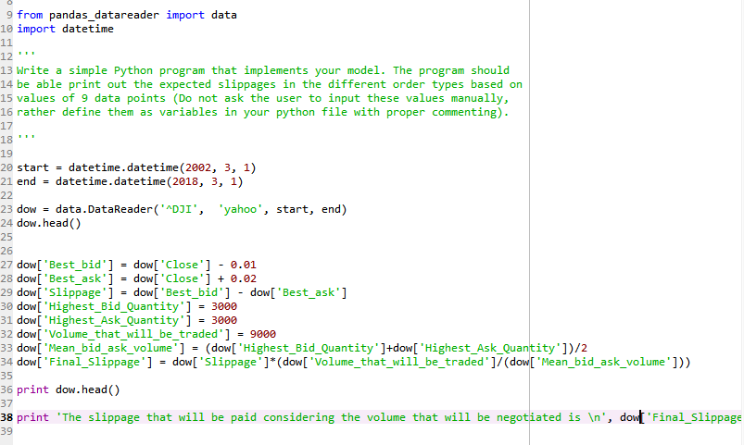

Results:

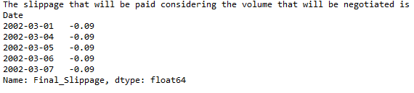

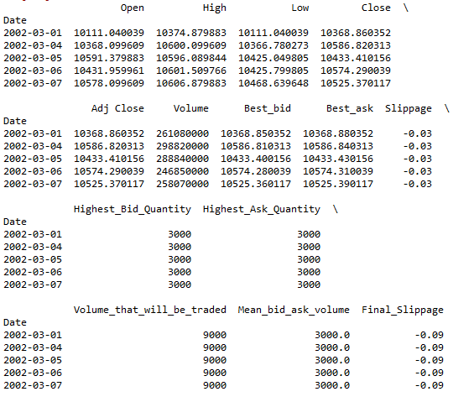

[1] <https://www.investopedia.com/terms/s/stop-limitorder.asp>